1)
import java.util.*;
class Pavan{
public static void main(String args[]){
Scanner sc=new Scanner(System.in);
System.out.println("E.pavan kumar reddy\n51834760");
System.out.println("enter size of array");
int n=sc.nextInt();
int temp=0;
int count=0;
int arr[]=new int[n];
System.out.println("enter all elements");
for(int i=0;i<n;i++){
arr[i]=sc.nextInt();
}
Arrays.sort(arr);
System.out.println("output: ");
System.out.println(arr[3]);

}

}

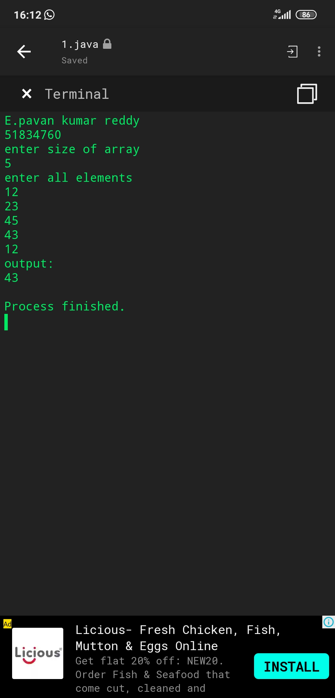

2)
import java.util.*;
class Pavan{
public static void main(String args[]){
Scanner sc=new Scanner(System.in);
System.out.println("E.pavan kumar reddy\n51834760");
System.out.println("enter the n");
int n=sc.nextInt();
for(int i=1;i<n+2;i++){
for(int j=1;j<i;j++){
System.out.print(j+",");
}
System.out.print(" ");
}
}

}
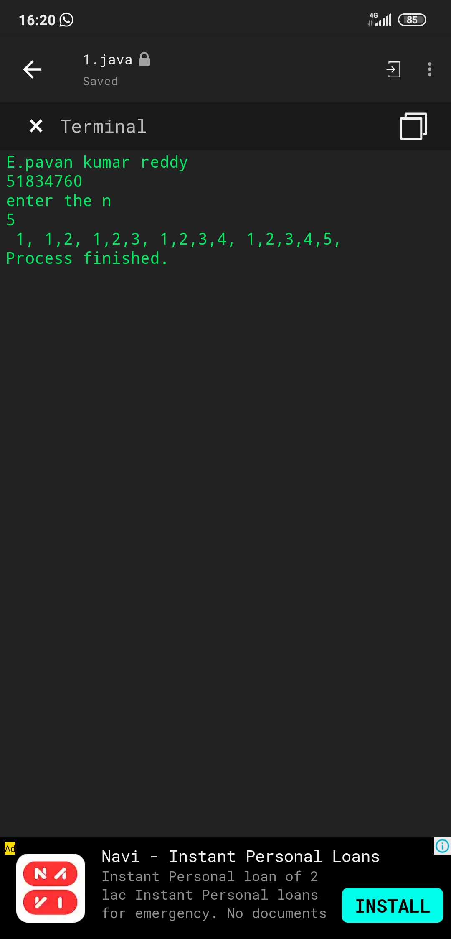

3)
import java.util.*;
interface Laptop{
abstract public void area();
abstract public void company();
abstract public void ram();
}
class Your_name implements Laptop{
public void area(){
System.out.println("100 sq.in");
}
public void company(){
System.out.println("company is asus");
}
public void ram(){
System.out.println("12 gb ram");
}

public static void main(String[] args){
Your_name o=new Your_name();
System.out.println("E.pavan kumar reddy\n51834760");

o.area();
o.company();
o.ram();
}
}
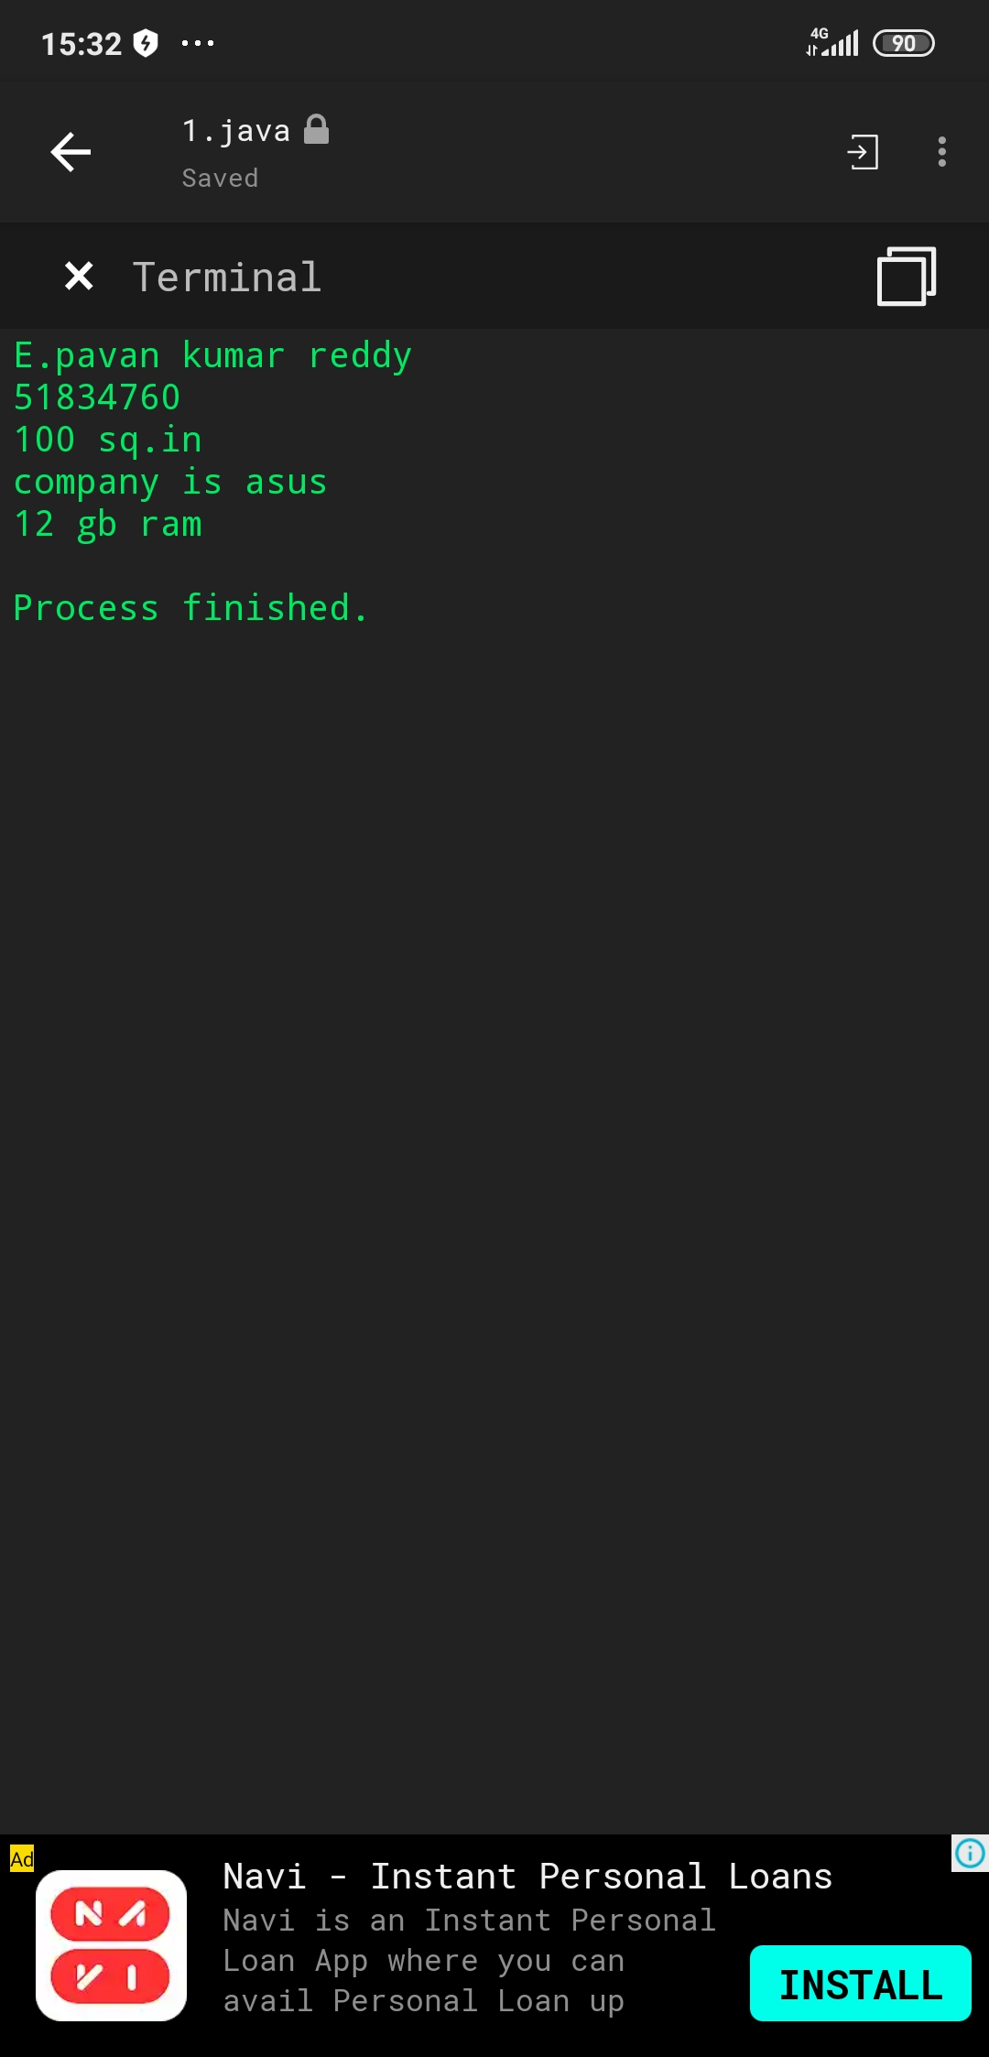

5)
import java.util.*;
class Pavan{
public static void main(String args[]){
Scanner sc=new Scanner(System.in);
System.out.println("enter no.of words");
int n=sc.nextInt();
String str;
String s="";
String arr[]=new String[n+1];
System.out.println("enter all words");
for(int i=0;i<n+1;i++){
arr[i]=sc.nextLine();
}
for(int i=0;i<n+1;i++) {

str=arr[i];

for(int j=str.length()-1;j>=0;j--){
s=s+str.charAt(j);
}
System.out.print(s+" ");
s="";

}

}
}
